Software Requirements Specification
SRS_mBK_1.0

Version 1.0

Class Name | Android
Class Code | Android-k16
Group | mBackup
Teacher | Khanh.Nguyen
Project Manager | Khanh.Nguyen
Assign Date | Oct-10-2011
Complete Date | Oct-23-2011
Author | mBackup-K16 Group
Version | 1.0
Approved By
Approved Date

Table of Contents
1. Introduction 4
1.1 Purpose 4
1.2 Scope 4
1.3 Definitions, Acronyms and Abbreviations 4
1.4 References 4
2. OVERAL Description 4
2.1 Product Perspective 4
2.2 Product Features 4
2.3 User Documents 4
2.4 Assumptions 5
2.5 Constraints 5
3. Use case model 5
3.1 The Actors 5
3.2 The use cases 5
3.3 Use cases diagram 8
3.3.1 Main use cases diagram: 8
3.3.2 Backup and restore Contact use cases diagram: 9
3.3.3 Backup and restore SMS use cases diagram: 9
3.3.4 Backup and restore Image/Media use cases diagram: 10
3.3.5 Backup and restore Files/Folder use cases diagram: 10
4. Functional Requirements 11
4.1 Feature Backup and restore contact: 11
4.1.1 Use case Backup (Contact) To SD Card _ BK1.1.0 11
4.1.2 Use case Backup (Contact) To Email _ BK1.1.1: 12
4.1.3 Use case Backup (Contact) To Dropbox _ BK1.1.2: 13
4.1.4 Use case Backup (Contact) To Server _ BK1.1.3: 14
4.1.5 Use case Restore (Contact) From SD Card _ BK1.2.0 15
4.1.6 Use case Restore (Contact) From Email _ BK1.2.1: 15
4.1.7 Use case Restore (Contact) To Dropbox _ BK1.2.2: 16
4.1.8 Use case Restore (Contact) To Server _ BK1.2.3: 17
4.1.9 Use Manage Backup Contact Files _ BK1.3.0: 18
4.1.10 Use case Schedule Backup Contact _ BK1.4.0: 19
4.1.11 Use case Select Backup Contact Type _ BK1.5.0: 20
4.2 Feature Backup and restore SMS: 21
4.3 Feature Backup and restore Images/media: 21
4.4 Feature Backup and restore Files/Folder: 21
5. Non-Functional Requirements 21
5.1 Usability 21
5.2 Reliability 21
5.3 Performance 21
5.4 Supportability 21
5.5 Interface Requirements 21
5.6 Security Requirements 21
5.7 Reports and Form templates Requirements 21
5.7.1 Reports 22
5.7.1.1 <Functional Name 1> Reports 22
5.7.2 Form Templates 22
5.7.2.1 <Functional Name 1> Forms 22
5.8 Other 22
5.8.1 <Feature 1> 22
5.8.2 <Feature 2> 22
6. Conclusion 22

Introduction
mBackup application is a project software, written on Android platform. It helps Users to ‘backup’ and ‘restore’ data of phone book, SMS, image/Media, files/folders in case Users lost phone or lost data.

Purpose
This Software Requirement Specification provides a complete description of all mBackup software requirements.

Scope
This document is applied for the mBackup project.

Definitions, Acronyms and Abbreviations
Term | Definitions, Acronyms and Abbreviations
SRS | Software Requirements Specification
mBackup | Name of project

References

OVERAL Description

Product Perspective
mBackup application will be run on an Android OS version 2.X (Ex: OS 2.0, OS 2.1, OS 2.2, OS 2.3).
This application will be developed on Eclipse, ADT plug-in version 12 or higher, base on java language, Android SDK r12 or higher.

Product Features
Following main features will be implemented available for the application:
- Backup and restore Contact.
- Backup and restore SMS.
- Backup and restore images/media.
- Backup and restore file/folders.

User Documents
- Software Requirements Specification document (SRS document).
- Software Design Specification document (SDS document).
- User manual document.
- Install manual document.

Assumptions
- Dropbox services always run.

Constraints
- Devices can run this application are smartphones use Android OS version 2.0 or higher.

Use case model

The Actors
- User: a person uses this application on smartphone Android.

The use cases
System Features | Main Use Case | Use Case ID
Backup and restore Contact
 | Display List Contacts | BK1.0.0
 | Select Contacts To Backup | BK1.0.1
 | Backup Contact To SD Card | BK1.1.0
 | Backup Contact To Email | BK1.1.1
 | Backup Contact To Server | BK1.1.2
 | Backup Contact To Dropbox | BK1.1.3
 | Restore Contact From SD Card | BK1.2.0
 | Restore Contact From Email | BK1.2.1
 | Restore Contact From Server | BK1.2.2
 | Restore Contact From Dropbox | BK1.2.3
 | Manage Backup Contact Files | BK1.3.0
 | Schedule Backup Contact | BK1.4.0
 | Select Backup Contact Type | BK1.5.0
Backup and restore SMS
 | Display List SMSs | BK2.0.0
 | Select SMSs To Backup | BK2.0.1
 | Backup SMS To SD Card | BK2.1.0
 | Backup SMS To Email | BK2.1.1
 | Backup SMS To Server | BK2.1.2
 | Backup SMS To Dropbox | BK2.1.3
 | Restore SMS From SD Card | BK2.2.0
 | Restore SMS From Email | BK2.2.1
 | Restore SMS From Server | BK2.2.2
 | Restore SMS From Dropbox | BK2.2.3
 | Manage Backup SMS Files | BK2.3.0
 | Schedule Backup SMS | BK2.4.0
 | Select Backup SMS Type | BK2.5.0
Backup and restore Images/Media
 | Display List Images/Media | BK3.0.0
 | Select Images/Media To Backup | BK3.0.1
 | Backup Images/Media To SD Card | BK3.1.0
 | Backup Images/Media To Email | BK3.1.1
 | Backup Images/Media To Server | BK3.1.2
 | Backup Images/Media To Dropbox | BK3.1.3
 | Restore Images/Media From SD Card | BK3.2.0
 | Restore Images/Media From Email | BK3.2.1
 | Restore Images/Media From Server | BK3.2.2
 | Restore Images/Media From Dropbox | BK3.2.3
 | Manage Backup Images/Media Files | BK3.3.0
 | Schedule Backup Images/Media | BK3.4.0
 | Select Backup Images/Media Type | BK3.5.0
Backup and restore files/folder
 | Display List Files/folder | BK4.0.0
 | Select Files/Folder To Backup | BK4.0.1
 | Backup Files/folder t To SD Card | BK4.1.0
 | Backup Files/folder To Email | BK4.1.1
 | Backup Files/folder To Server | BK4.1.2
 | Backup Files/folder To Dropbox | BK4.1.3
 | Restore Files/folder From SD Card | BK4.2.0
 | Restore Files/folder From Email | BK4.2.1
 | Restore Files/folder From Server | BK4.2.2
 | Restore Files/folder From Dropbox | BK4.2.3
 | Manage Backup Files/folder Files | BK4.3.0
 | Schedule Backup Files/folder | BK4.4.0
 | Select Backup Files/Folder Type | BK4.5.0

Use cases diagram

Main use cases diagram:
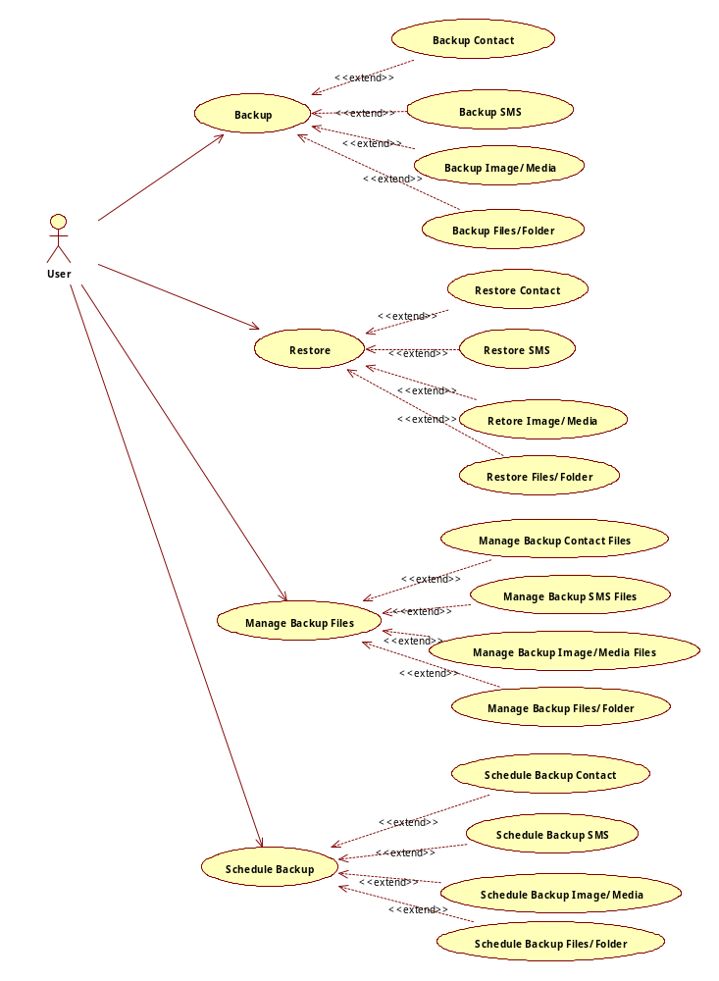

Backup and restore Contact use cases diagram:
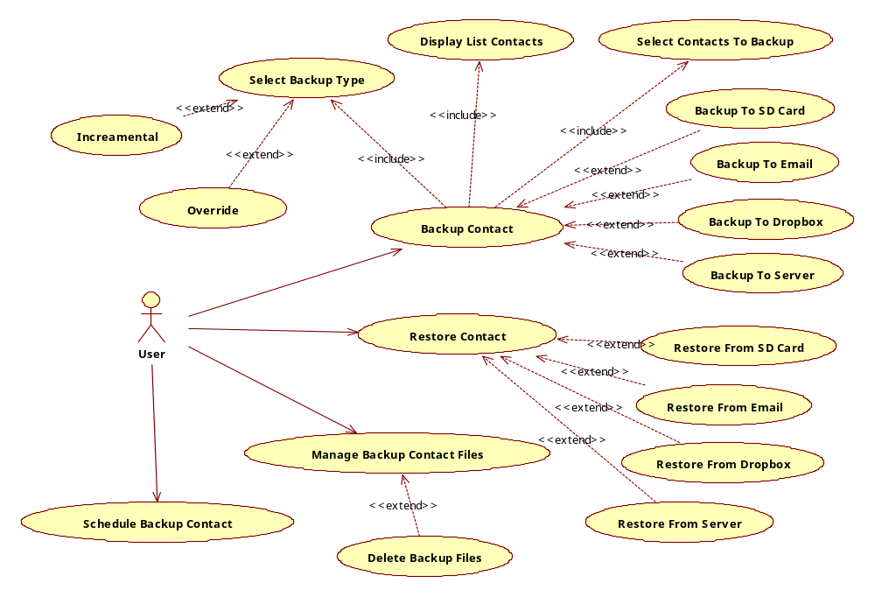

Backup and restore SMS use cases diagram:
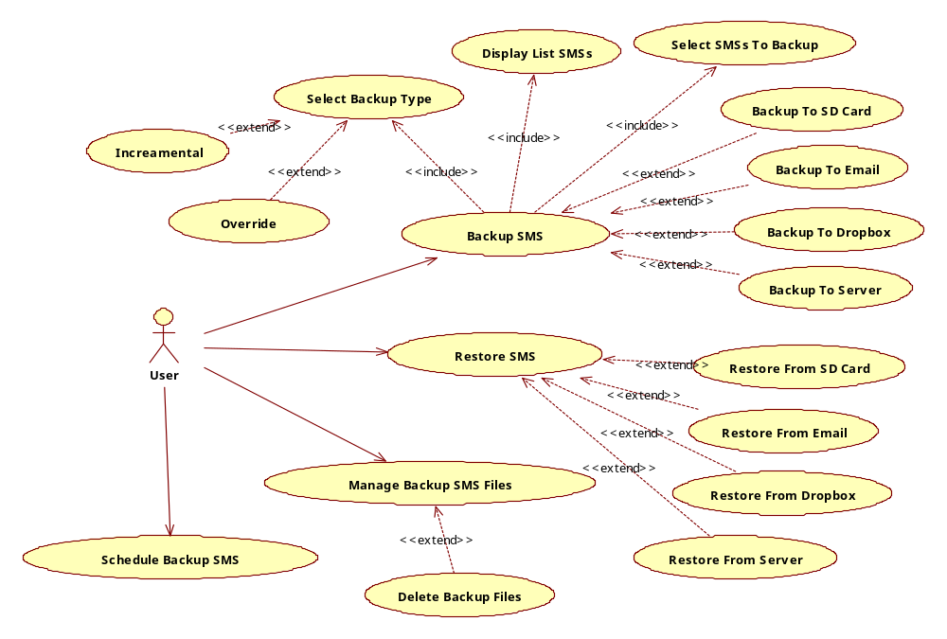

Backup and restore Image/Media use cases diagram:
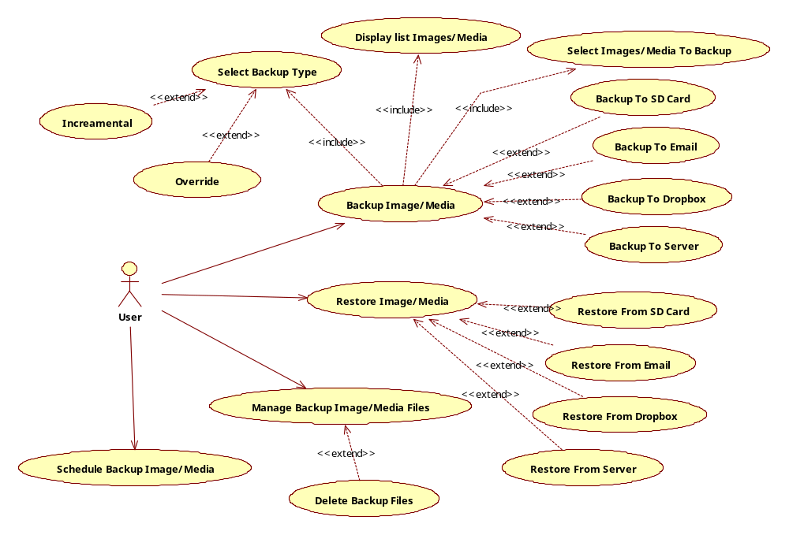

Backup and restore Files/Folder use cases diagram:
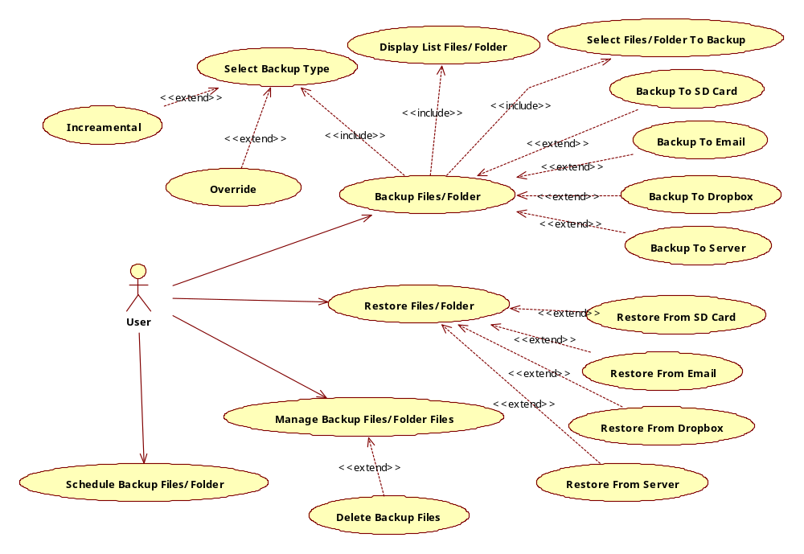

Functional Requirements

Feature Backup and restore contact:
Section/ Requirement ID | Requirement Definition
FR1.0 | The Application shall backup and restore contact to SD card.
FR1.1 | The Application shall backup and restore contact to Email
FR1.2 | The Application shall backup and restore contact to Dropbox.
FR1.3 | The Application shall backup and restore contact to Server.
FR1.4 | The Application shall let user manage list backup contact files ( view, delete)
FR1.5 | The Application shall let user put on schedule backup contact.(daily, weekly, monthly)

Use case Backup (Contact) To SD Card _ BK1.1.0
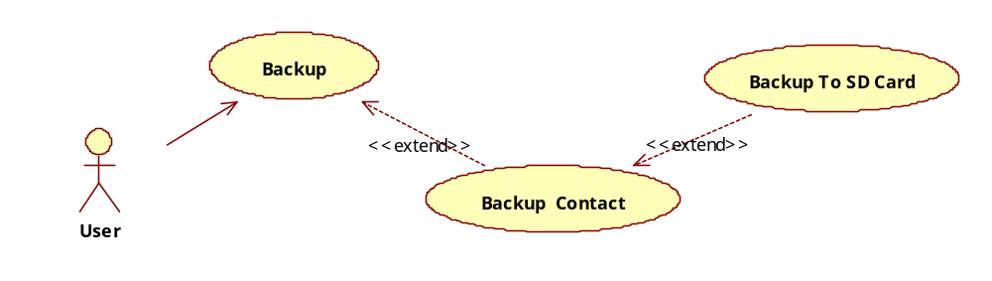
Use Case ID | BK1.1.0
Name | Backup Contact To SD Card or Backup To SD Card.
Goal | Backup Contact and save backup contact file at SD Card.
Actors | User
Include | No
Extended | No
Pre-conditions | - The Smartphone have to have SD Card.  - SD Card has enough to save the backup file.  - User selected list contacts to backup.
Post-conditions | A backup file will be stored in SD card.
Main Flow | - Select Backup Contact To SD Card function.  - Enter backup file name and click “OK” button. Or Click “Cancel” button to cancel  8. Finishes Function and begins again. | - Display Edit text to enter backup file name.  4. Display Process Dialog.  5. Read Contacts were selected and write to file.  6. Write the file to SD Card.  7. Display Finish Dialog.
Exceptions | 6.1: If Not found SD Card, it will remind user “Not Found SD Card!” and finish.  6.2: If SD Card don’t enough memory, it will remind user “ SD Card don’t enough memory to save this backup file.” And Finish.
Open Issues | No

Use case Backup (Contact) To Email _ BK1.1.1:
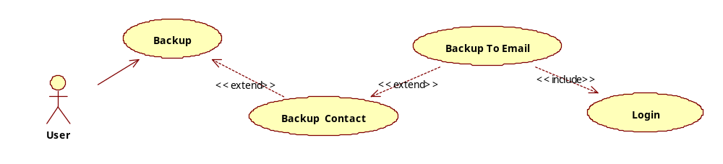
Use Case ID | BK1.1.1
Name | Backup Contact To Email or Backup To Email.
Goal | Backup Contact and save backup contact file at Email.
Actors | User
Include | Login
Extended | No
Pre-conditions | - User have to login successful user’s email.  - Smartphone have to connect internet.
Post-conditions | A backup file will be stored in user’s email.
Main Flow | 1.Select Backup Contact To Email function.  4.Enter backup file name and click “OK” button. Or Click “Cancel” button to cancel  9. Finishes Function and begins again. | 2.Run Login function. If login success, going to step 3. Else Callback Login function.  3.Display Edit text to enter backup file name.  5. Display Process Dialog.  6. Read Contacts were selected and write to file.  7. Upload the file to the email.  8. Display Finish Dialog.
Exceptions | 1.1: If Not found any connection to internet, this application show messagebox: “Please, checking connection to internet on your smartphone.” Then, Finishes function and begin again.  2.1 If Login failed, this application display messagebox: “Please checking username, password of you.” Then Callback Login function.
Open Issues | No

Use case Backup (Contact) To Dropbox _ BK1.1.2:
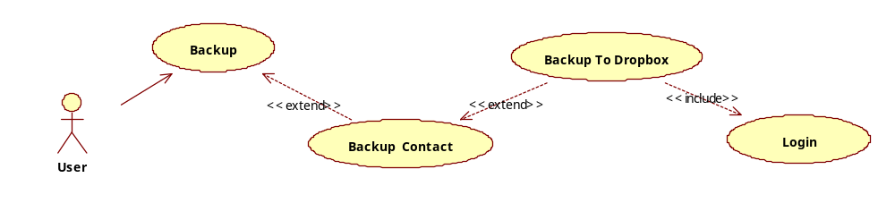
Use Case ID | BK1.1.2
Name | Backup Contact To Dropbox or Backup To Dropbox.
Goal | Backup Contact and save backup contact file at Dropbox.
Actors | User
Include | Login
Extended | No
Pre-conditions | - User have to login successful user’s account Dropbox.  - Smartphone have to connect internet.
Post-conditions | A backup file will be stored in user’s account Dropbox.
Main Flow | 1.Select Backup Contact To Dropbox function.  4.Enter backup file name and click “OK” button. Or Click “Cancel” button to cancel  9. Finishes Function and begins again. | 2.Run Login function. If login success, going to step 3. Else Callback Login function.  3.Display Edit text to enter backup file name.  5. Display Process Dialog.  6. Read Contacts were selected and write to file.  7. Upload the file to the account dropbox  8. Display Finish Dialog.
Exceptions | 1.1: If Not found any connection to internet, this application show messagebox: “Please, checking connection to internet on your smartphone.” Then, Finishes function and begin again.  2.1 If Login failed, this application display messagebox: “Please checking username, password of you.” Then Callback Login function.
Open Issues | No

Use case Backup (Contact) To Server _ BK1.1.3:
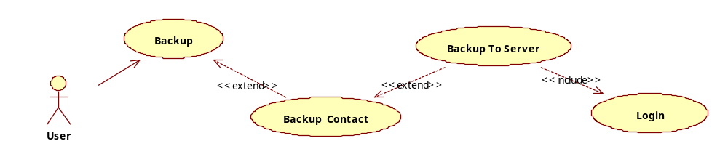

Use Case ID | BK1.1.3
Name | Backup Contact To Server or Backup To Server.
Goal | Backup Contact and save backup contact file at a third-party storage server.
Actors | User
Include | Login
Extended | No
Pre-conditions | - User have to login successful user’s account third-party storage server.  - Smartphone have to connect internet.
Post-conditions | A backup file will be stored in third-party storage server.
Main Flow | 1.Select Backup Contact To Server function.  4.Enter backup file name and click “OK” button. Or Click “Cancel” button to cancel  9. Finishes Function and begins again. | 2.Run Login function. If login success, going to step 3. Else Callback Login function.  3.Display Edit text to enter backup file name.  5. Display Process Dialog.  6. Read Contacts were selected and write to file.  7. Upload the file to the third-party storage server.  8. Display Finish Dialog.
Exceptions | 1.1: If Not found any connection to internet, this application show messagebox: “Please, checking connection to internet on your smartphone.” Then, Finishes function and begin again.  2.1 If Login failed, this application display messagebox: “Please checking username, password of you.” Then Callback Login function.
Open Issues | No

Use case Restore (Contact) From SD Card _ BK1.2.0
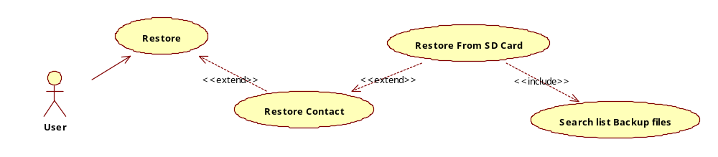
Use Case ID | BK1.2.0
Name | Restore Contact From SD Card or Restore From SD Card.
Goal | Restore contact from a backup contact file, saved at SD Card.
Actors | User
Include | Search list Backup Files
Extended | No
Pre-conditions | - The Smartphone have to have SD Card.
Post-conditions | A backup file will be restore from SD card to smartphone’s contact.
Main Flow | 1.Select Restore Contact From SD Card function.  3.User select a name file in list backup files name want to restore.  7. Finishes Function and begins again. | 2.Run Search list Backup files function.  4. Display Process Dialog.  5. Read file and restore.  6. Display Finish Dialog.
Exceptions | 1.1: If Not found SD Card, it will remind user “Not Found SD Card!” and finish.  2.1: If Not found any backup contact file, the application will show messagebox : “Not found any backup file!”. Then, Finishes function and begin again.
Open Issues | No

Use case Restore (Contact) From Email _ BK1.2.1:
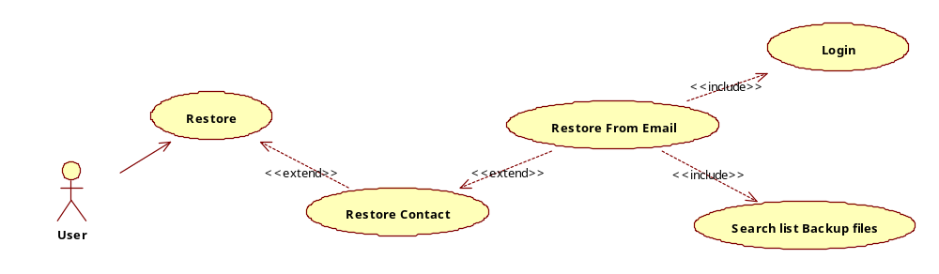
Use Case ID | BK1.2.1
Name | Restore Contact From Email or Restore From Email.
Goal | Restore contact from a backup contact file, saved at a user’s account email.
Actors | User
Include | Login, Search list Backup Files
Extended | No
Pre-conditions | - User have to login successful user’s email.  - Smartphone have to connect internet.
Post-conditions | A backup file will be restore from a user’s account email to smartphone’s contact.
Main Flow | 1.Select Restore Contact From Email function.  4.User select a name file in list backup files name want to restore.  8. Finishes Function and begins again. | 2.Run Login function. If login success, going to step 3. Else Callback Login function.  3.Run Search list Backup files function.  5. Display Process Dialog.  6. Read file and restore.  7. Display Finish Dialog.
Exceptions | 1.1: If Not found any connection to internet, this application show messagebox: “Please, checking connection to internet on your smartphone.” Then, Finishes function and begin again.  2.1 If Login failed, this application display messagebox: “Please checking username, password of you.” Then Callback Login function.  3.1: If Not found any backup contact file, the application will show messagebox : “Not found any backup file!”. Then, Finishes function and begin again.
Open Issues | No

Use case Restore (Contact) To Dropbox _ BK1.2.2:
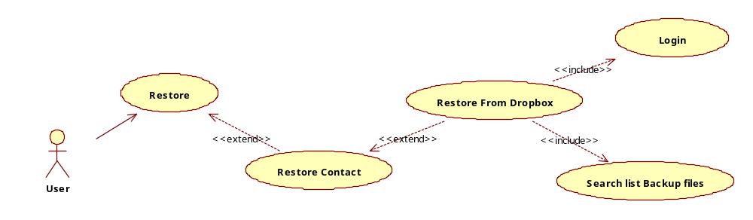
Use Case ID | BK1.2.2
Name | Restore Contact From Dropbox or Restore From Dropbox.
Goal | Restore contact from a backup contact file, saved at a user’s account dropbox.
Actors | User
Include | Login, Search list Backup Files
Extended | No
Pre-conditions | - User have to login successful user’s account Dropbox.  - Smartphone have to connect internet.
Post-conditions | A backup file will be restore from a user’s account dropbox to smartphone’s contact.
Main Flow | 1.Select Restore Contact From Dropbox function.  4.User select a name file in list backup files name want to restore.  8. Finishes Function and begins again. | 2.Run Login function. If login success, going to step 3. Else Callback Login function.  3.Run Search list Backup files function.  5. Display Process Dialog.  6. Read file and restore.  7. Display Finish Dialog.
Exceptions | 1.1: If Not found any connection to internet, this application show messagebox: “Please, checking connection to internet on your smartphone.” Then, Finishes function and begin again.  2.1 If Login failed, this application display messagebox: “Please checking username, password of you.” Then Callback Login function.  3.1: If Not found any backup contact file, the application will show messagebox : “Not found any backup file!”. Then, Finishes function and begin again.
Open Issues | No

Use case Restore (Contact) To Server _ BK1.2.3:
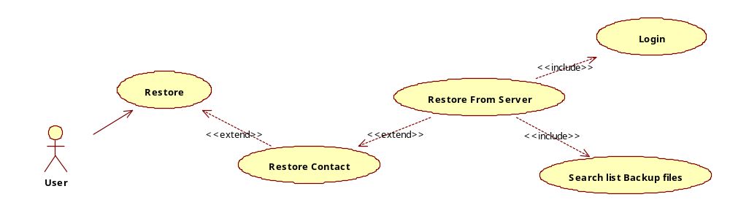

Use Case ID | BK1.2.3
Name | Restore Contact From Server or Restore From Server.
Goal | Restore contact from a backup contact file, saved at a user’s account third-party storage server.
Actors | User
Include | Login, Search list Backup Files
Extended | No
Pre-conditions | - User have to login successful user’s account third-party storage server.  - Smartphone have to connect internet.
Post-conditions | A backup file will be restore from a user’s account third-party storage server. to smartphone’s contact.
Main Flow | 1.Select Restore Contact From Server function.  4.User select a name file in list backup files name want to restore.  8. Finishes Function and begins again. | 2.Run Login function. If login success, going to step 3. Else Callback Login function.  3.Run Search list Backup files function.  5. Display Process Dialog.  6. Read file and restore.  7. Display Finish Dialog.
Exceptions | 1.1: If Not found any connection to internet, this application show messagebox: “Please, checking connection to internet on your smartphone.” Then, Finishes function and begin again.  2.1 If Login failed, this application display messagebox: “Please checking username, password of you.” Then Callback Login function.  3.1: If Not found any backup contact file, the application will show messagebox : “Not found any backup file!”. Then, Finishes function and begin again.
Open Issues | No

Use Manage Backup Contact Files _ BK1.3.0:
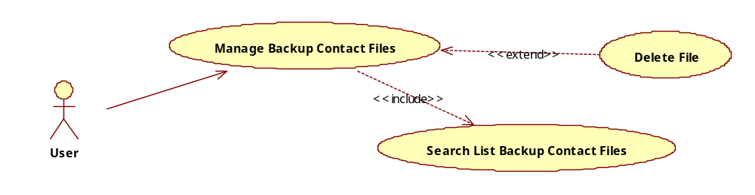

Use Case ID | BK1.3.0
Name | Manage Backup Contact Files
Goal | Manage list bakup contact files to view or delete file.
Actors | User
Include | Search list Backup Contact Files
Extended | Delete File
Pre-conditions | No
Post-conditions | No
Main Flow | 1.Select Manage Backup Contact Files function.  3.User select a name file in list backup files name want to delete or Cancel if not want  6. Finishes Function and begins again. | 2.Run Search list Backup Contact files function.  4. Delete file selected.  5. Display Finish Dialog.
Exceptions | 3.1: If Not found any backup contact file, the application will show messagebox : “Not found any backup file!”. Then, Finishes function and begin again.
Open Issues | No

Use case Schedule Backup Contact _ BK1.4.0:
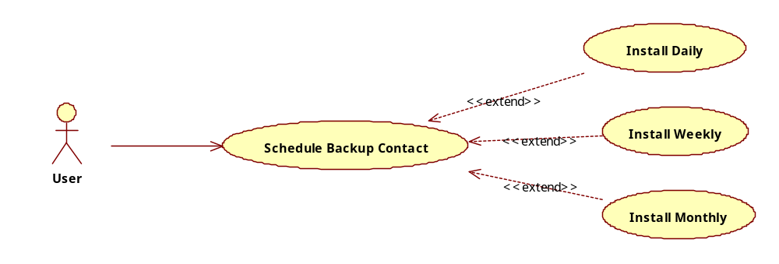
Use Case ID | BK1.4.0
Name | Schedule Backup Contact
Goal | Ínstall schedule backup contact as daily, weekly, monthly. Note: only one choice
Actors | User
Include | No
Extended | Ínstall Daily, Install Weekly, Install Monthly.
Pre-conditions | No
Post-conditions | No
Main Flow | 1.Select Schedule Backup Contact function.  2.User select a choice from list choises: daily, weekly, monthly.  4.User select “Save” button to save install.  6.Finishes function and begins again. | 3.Run function as selection.  5.Display Finish Dialog.
Exceptions | No
Open Issues | No

Use case Select Backup Contact Type _ BK1.5.0:
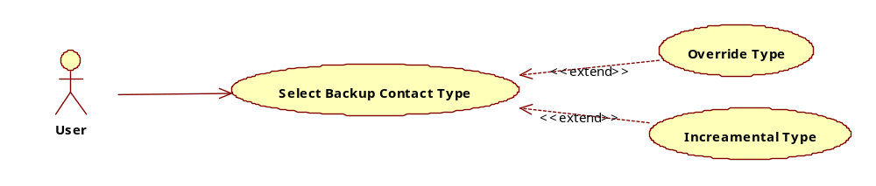
Use Case ID | BK1.5.0
Name | Select Backup Contact Type
Goal | Select backup type to backup contact.
Actors | User
Include | No
Extended | Override Type, Increamental Type
Pre-conditions | No
Post-conditions | No
Main Flow | 1.Select Select Backup Contact Type function.  2.User select Override Type or Increamental Type.  4.User select “Save” button to save install.  6.Finishes function and begins again. | 3.Save option selected.  5.Display Finish Dialog.
Exceptions | No
Open Issues | No

Feature Backup and restore SMS:
Define and description similar with Feature Backup and restore Contact.

Feature Backup and restore Images/media:
Define and description similar with Feature Backup and restore Contact.

Feature Backup and restore Files/Folder:
Define and description similar with Feature Backup and restore Contact.

Non-Functional Requirements

Usability

Reliability

Performance
- The mBackup application can run a lot of function backup as SMS, Contact or Image, Files.
- Run time for a backup times is 1 minute/file have file size is 1MB.

Supportability
- TMA coding standard.
- Include DLL of dropbox service.
- Include DLL of email service.

Interface Requirements
<Introduction/description>
No. | Interface Process Name | Import / Export | Functional Affected | Purpose | Frequency

Security Requirements
No

Reports and Form templates Requirements
<Introduction/description>

Reports
<Introduction/description>

<Functional Name 1> Reports

No. | Report Name | Usage | Description | Input Parameter(s) | Frequency

Form Templates
<Introduction/description>

<Functional Name 1> Forms
No. | Form Name | Usage | Description

Other
<Introduction/description>

<Feature 1>

<Feature 2>

Conclusion

---------- End of Document ----------

